DOCUMENTATION
Retail Store Sales Data Analysis and Visualization

Objective
The objective of this project is to clean and analyze retail store sales data using Microsoft Excel and visualize key sales insights using Power BI. The project focuses on sales performance across categories, locations, payment methods, and time periods through an interactive dashboard.
Dataset Description
The project uses an edited Retail Store Sales dataset containing 999 transaction records and 11 columns. The dataset includes numerical, categorical, Boolean, and date fields and was cleaned and prepared in Microsoft Excel before being used for analysis and visualization in Power BI.

Data Cleaning and Transformation

1.Check for Duplicate Records
The dataset was checked for duplicate records using Excel's Remove Duplicates feature. The relevant dataset range was selected and Excel was used to identify whether any duplicate records existed.

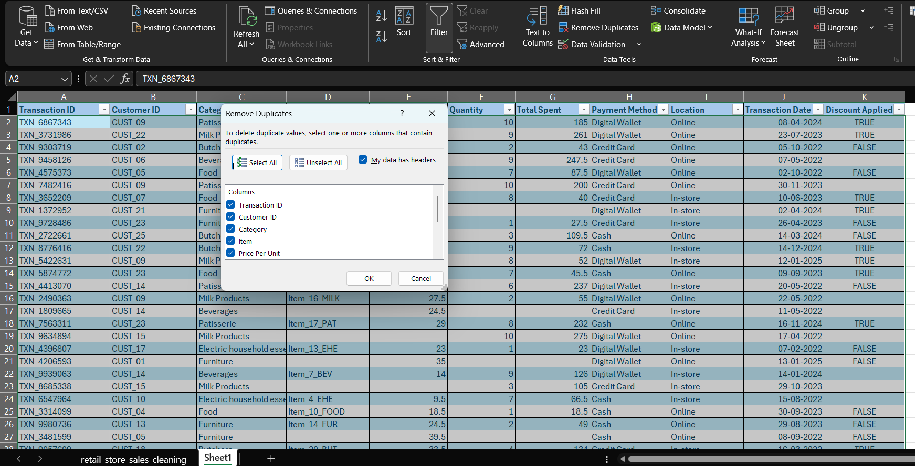

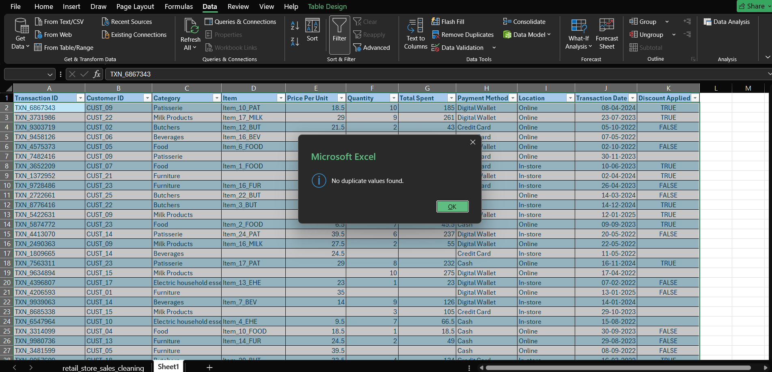

2.Checking Missing Values in the Item Column
The Item column was checked using Excel’s Filter option. The presence of (Blanks) confirmed that missing values were present.

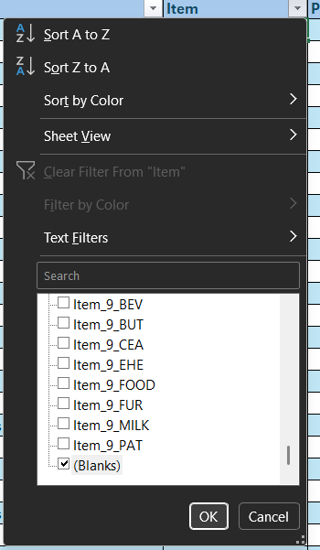
Blank values in the Item column were identified and replaced with “UNKNOWN ITEM.”

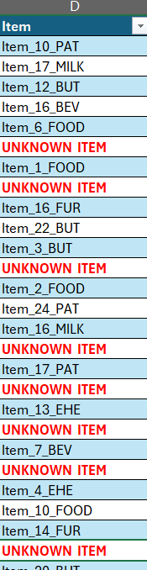
3.Handling Numerical Values
The average values for Price Per Unit and Quantity were calculated using the AVERAGE function and rounded using the ROUND function. The resulting values, 23.26 and 6, were used for handling missing numerical values.
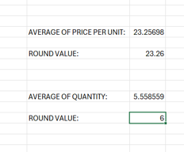
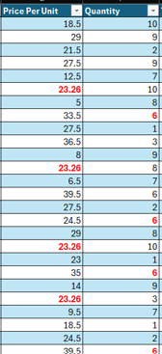
4.Calculating Total Spent
The Total Spent column was calculated by multiplying Price Per Unit by Quantity for each transaction.

=[@[Price Per Unit]]*[@[Quantity]]

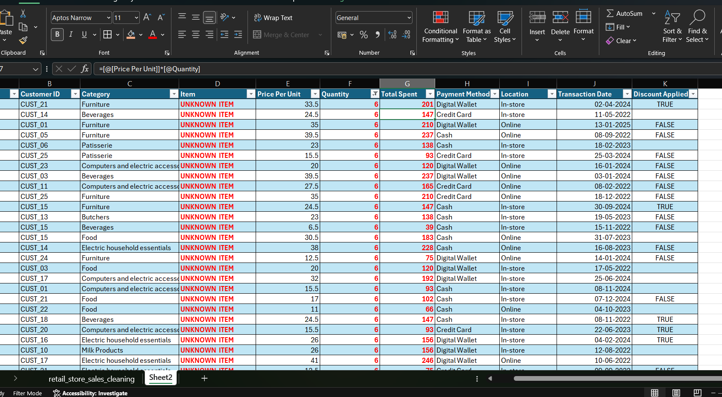

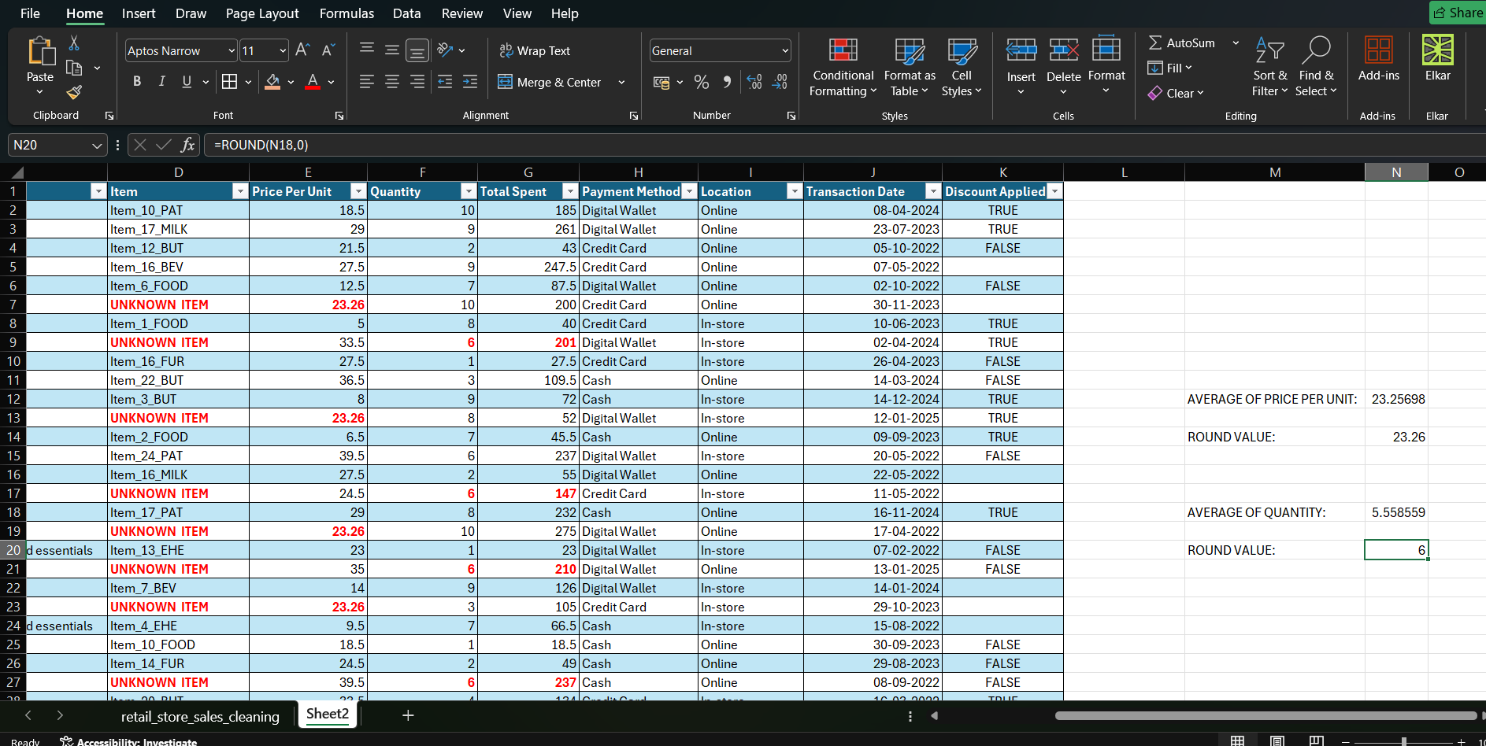

5.Handling Missing Values in Discount Applied
The Discount Applied column was checked for missing values. The existing TRUE and FALSE values were counted using the COUNTIF function.
- TRUE count: 312
- FALSE count: 365
Since FALSE occurs more frequently, it was identified as the mode and used to replace the missing values in the column.
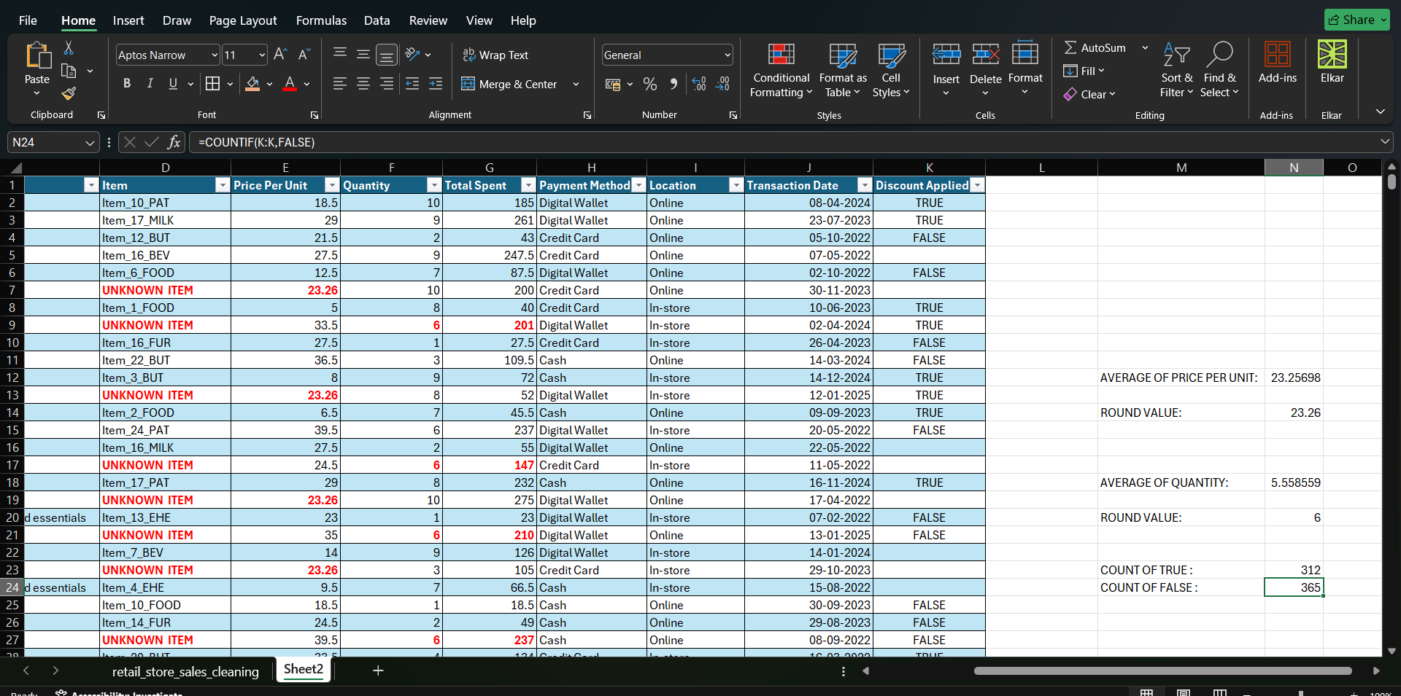
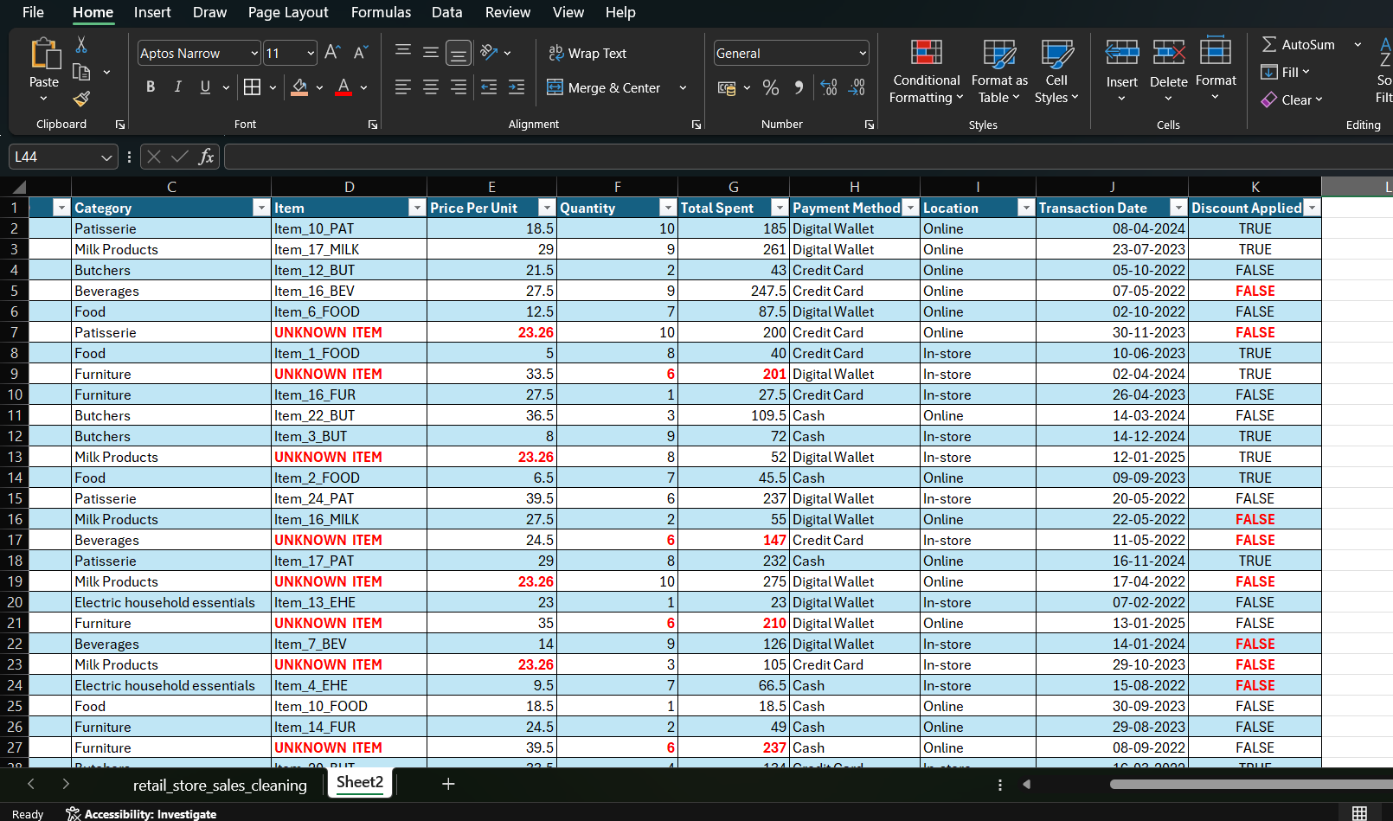
6.Sorting Transaction Dates chronologically
The Transaction Date column was sorted in Oldest to Newest order using the Excel Sort option. This arranged the records chronologically, starting from the earliest transaction date.
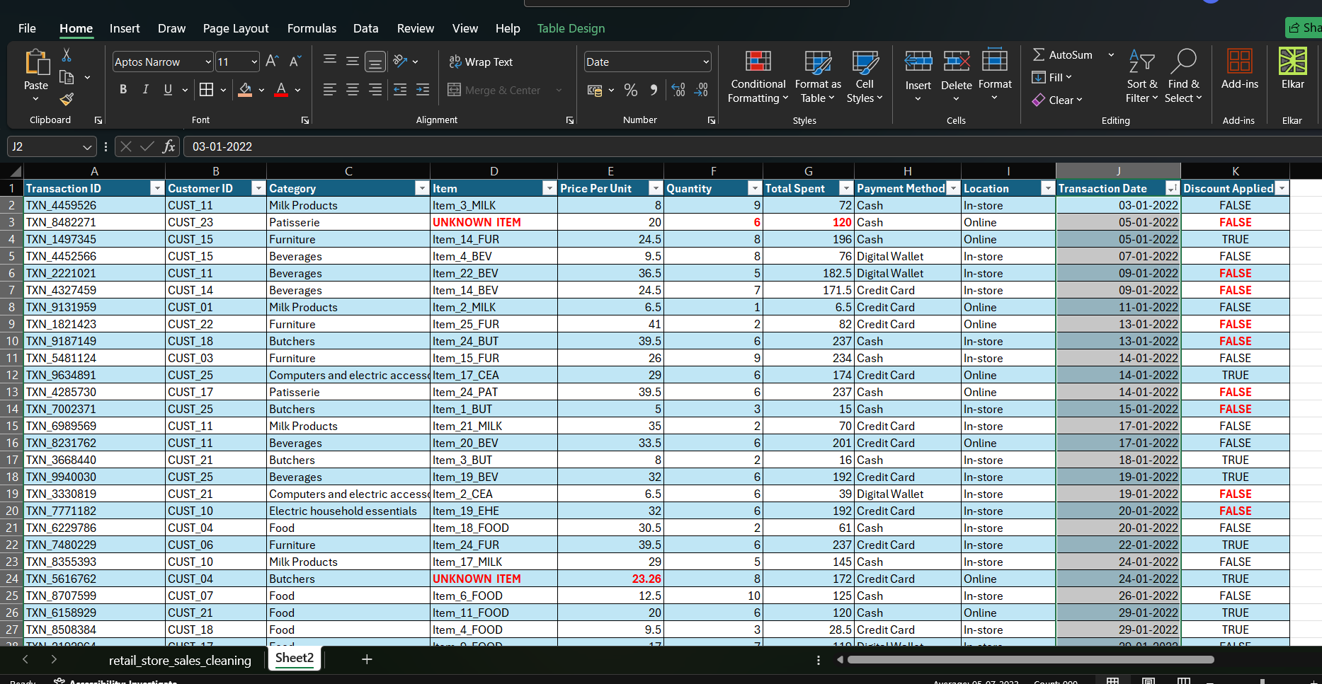



Creating Pivot Tables for Data Analysis
1. Total Spent by Category
A Pivot Table was created to analyze the Total Spent across different product categories. The Category field was added to the Rows area, while Total Spent was added to the Values area and summarized using Sum. This provides the total sales amount for each category.
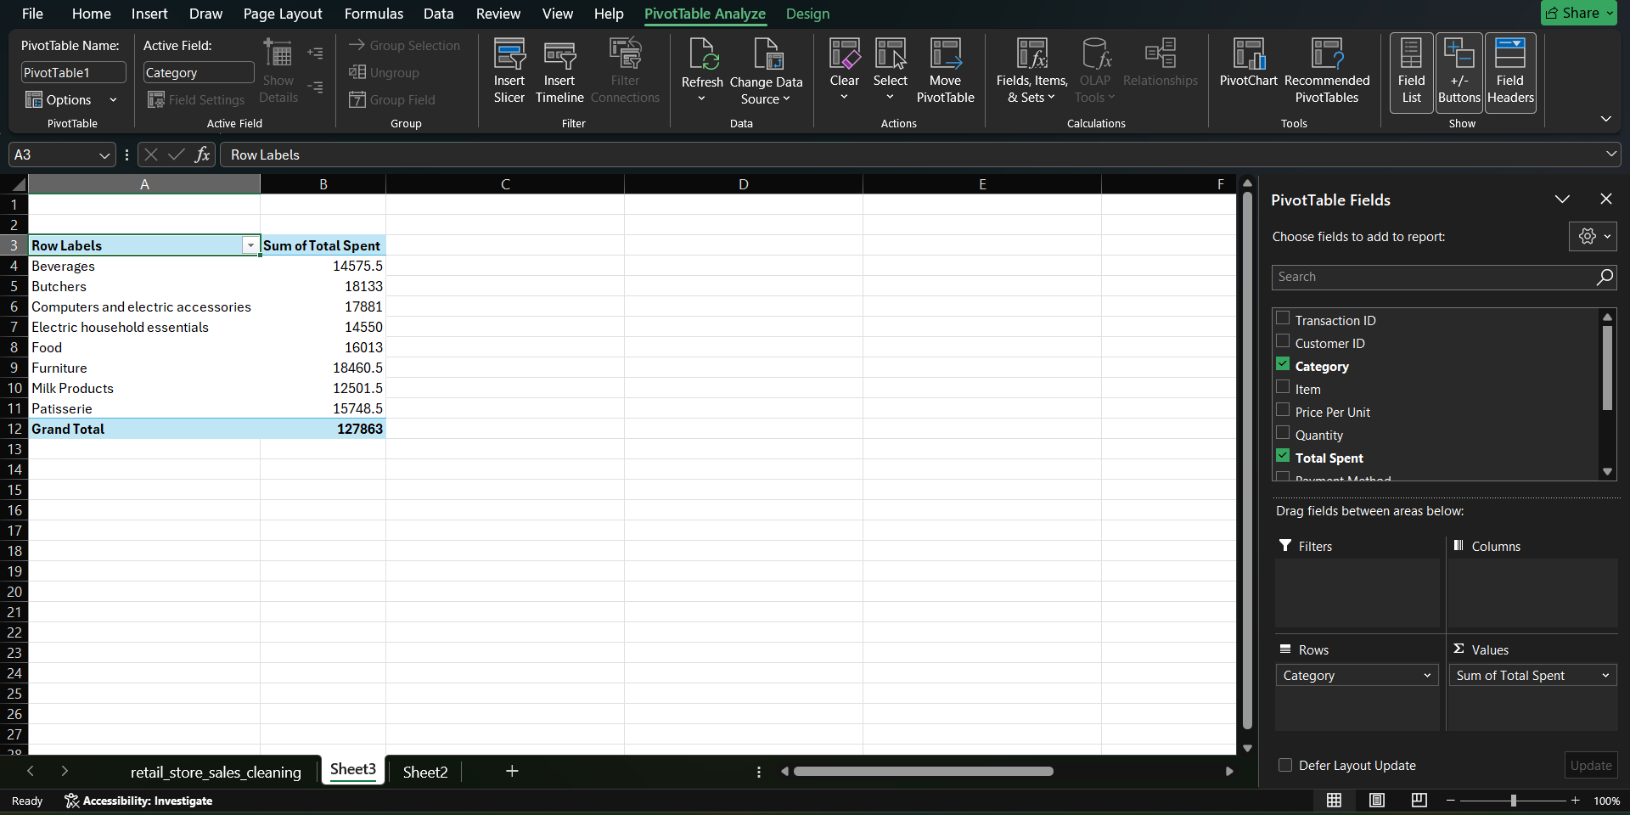
2.Total Spent by Payment Method
A Pivot Table was created to analyze Total Spent based on different payment methods. The Payment Method field was placed in the Rows area, while Total Spent was added to the Values area and summarized using Sum.
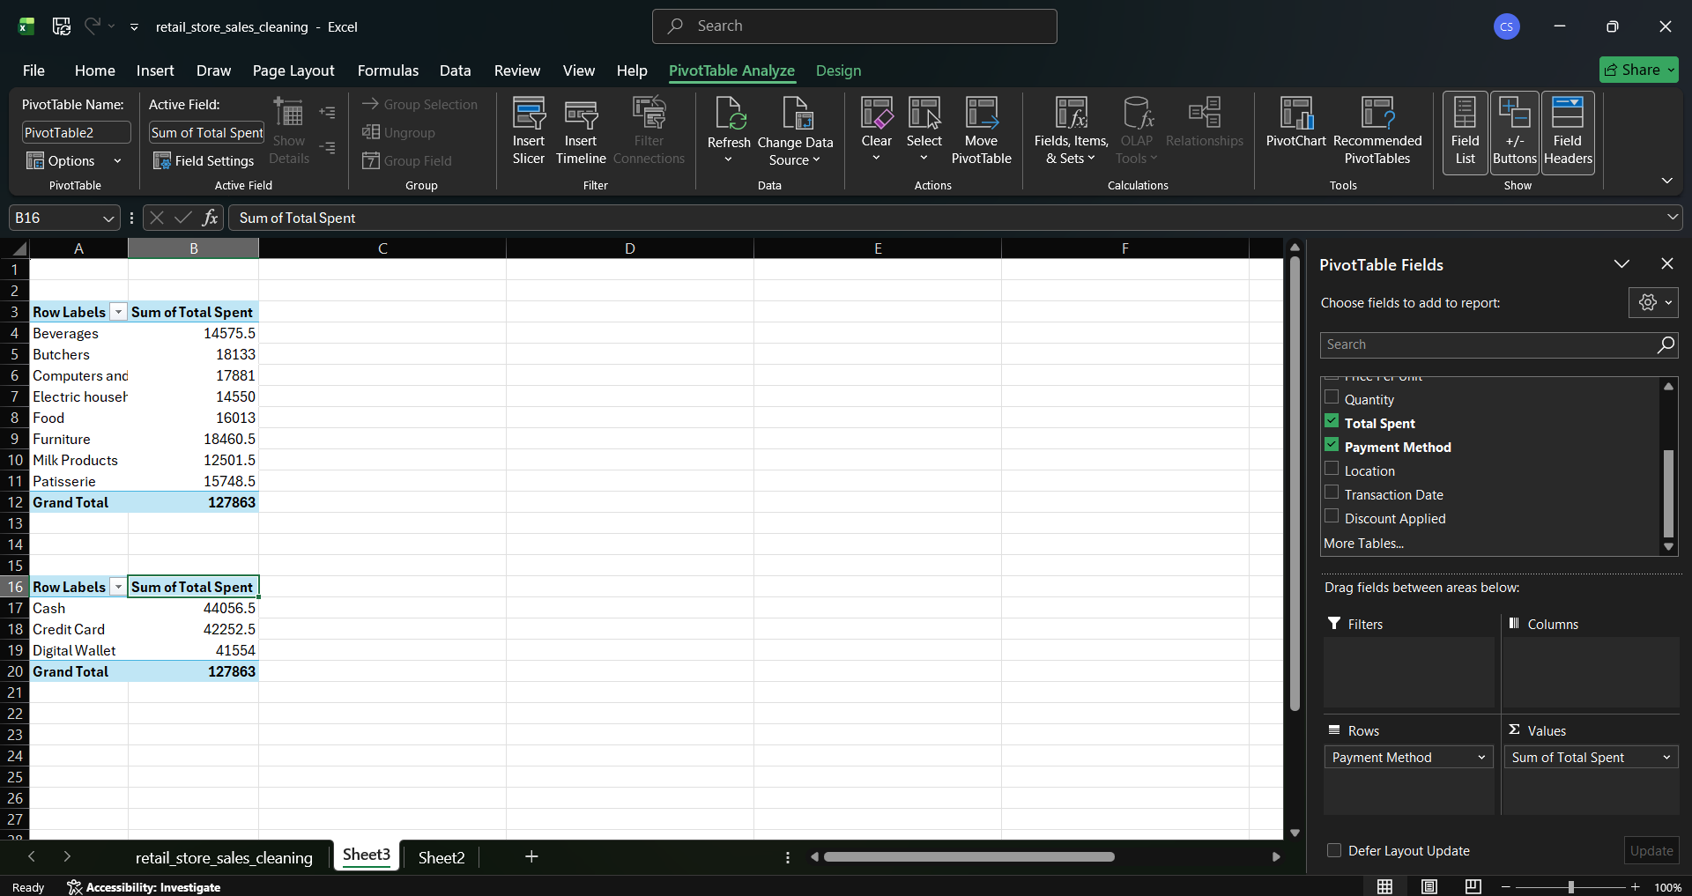
3.Total Spent by Location
A Pivot Table was created to analyze Total Spent based on the purchase location. The Location field was placed in the Rows area, while Total Spent was added to the Values area and summarized using Sum.
This compares sales between In-store and Online purchases.
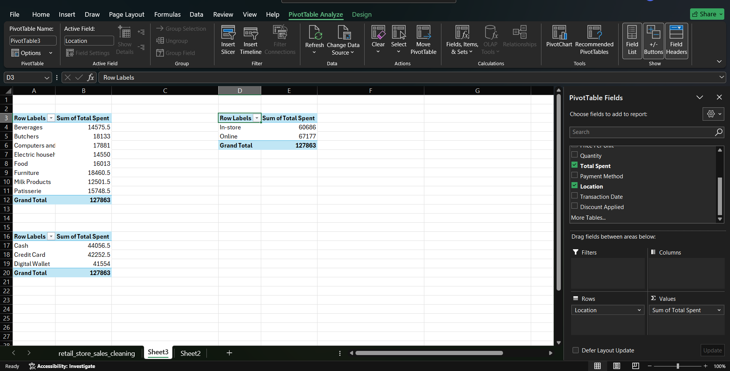
4.Total Spent by Year
A Pivot Table was created to analyze Total Spent by year. The Transaction Date was grouped by Years and placed in the Rows area, while Total Spent was added to the Values area and summarized using Sum.This helps compare the overall sales performance across different years.
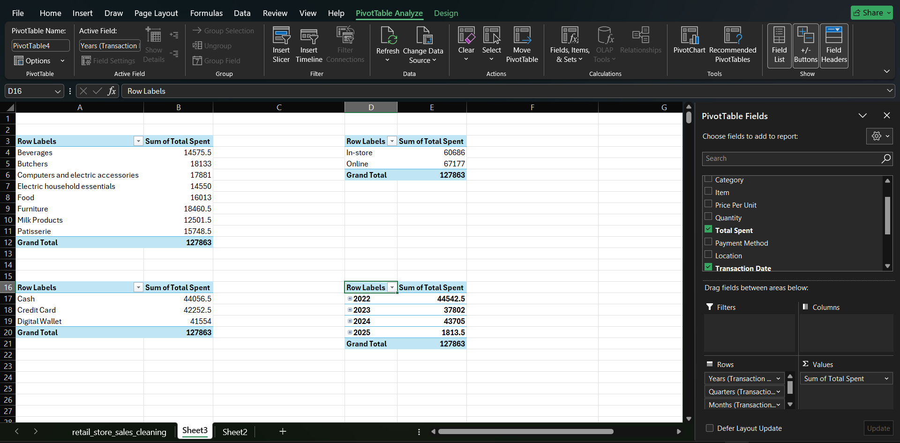
5.Total Spent by Discount Applied
A Pivot Table was created to analyze Total Spent based on whether a discount was applied. The Discount Applied field was placed in the Rows area, and Total Spent was added to the Values area using the Sum function.
This helps compare total spending between transactions where a discount was TRUE or FALSE.
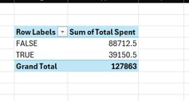

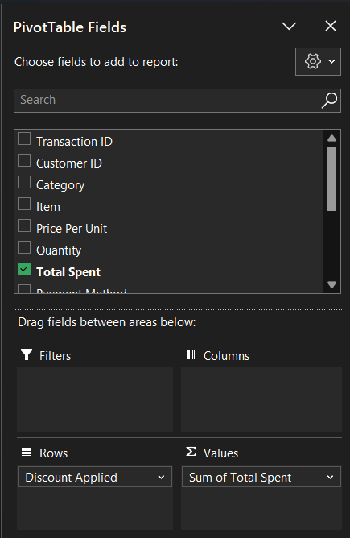

Power BI – Data Analysis and Visualization
1. Importing the Cleaned Dataset
The cleaned Retail Store Sales dataset was imported from Excel into Power BI. The CLEANED DATA table was selected from the workbook and loaded into Power BI for further analysis and visualization.
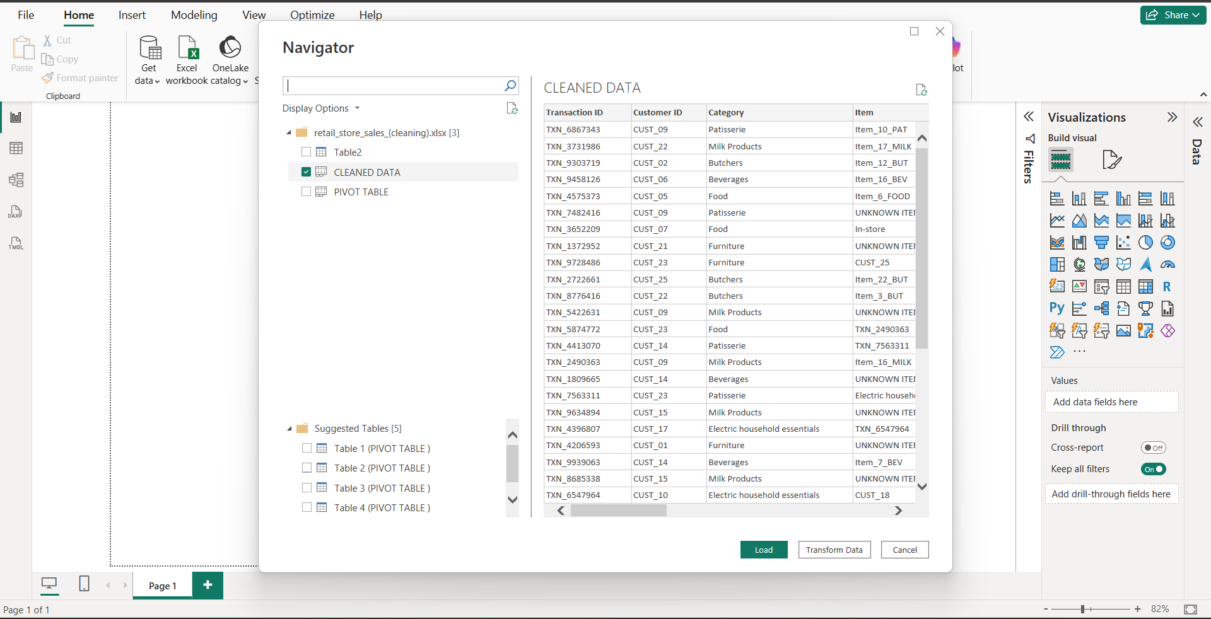
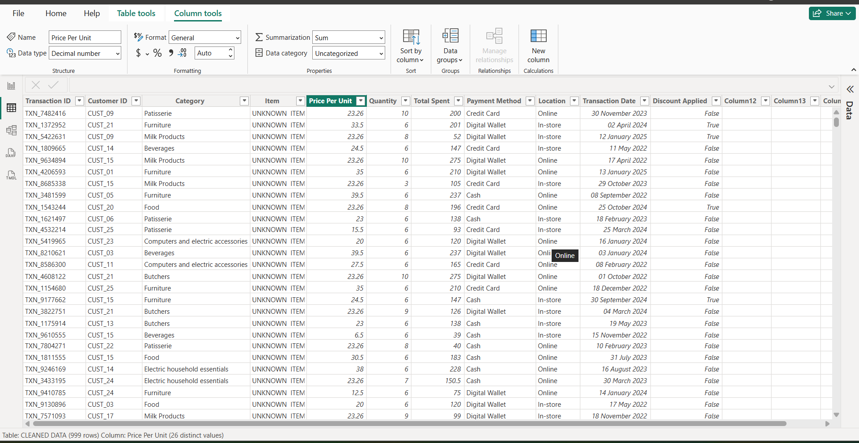

2. Creating DAX Measures
Creating the Total Sales Measure
A DAX measure was created to calculate the overall sales amount from the Total Spent column.
The formula used was:
Total Sales = SUM ('CLEANED DATA'[Total Spent])
The measure calculates the total spending across all transactions and was later used in the dashboard.
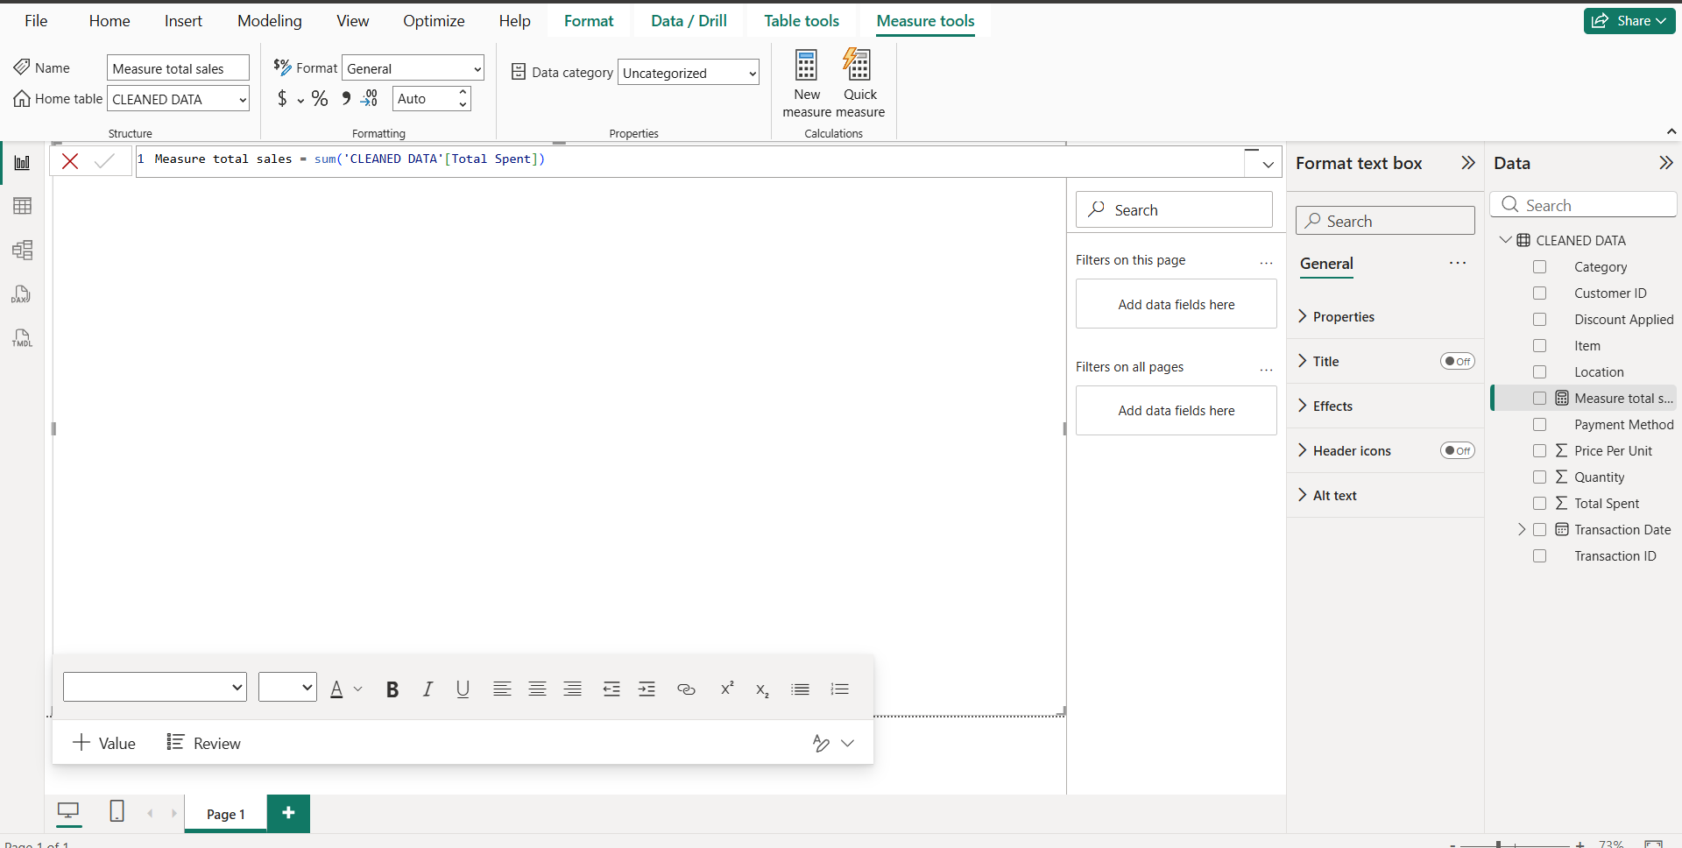

3. Creating KPI Cards
Three Card visuals were created to display the key sales metrics:
- Total Sales: 127.86K
- Total Transactions: 999
- Average Total Spent: 127.99
These cards provide a quick overview of the overall sales performance.

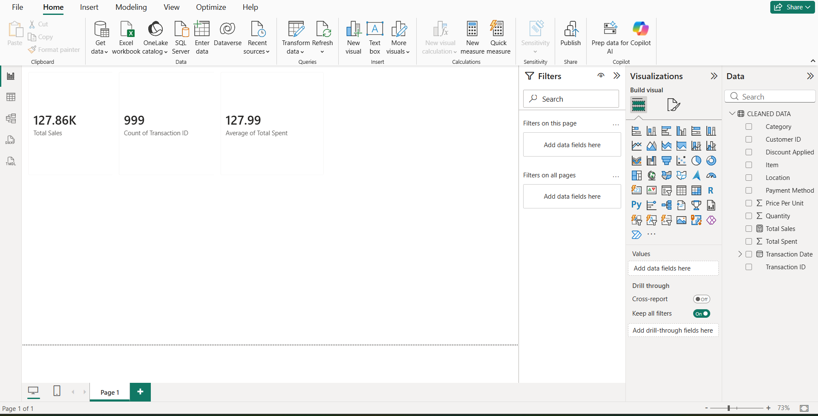

1. Total Sales – Card
A Card visual displays the overall sales generated from all transactions. The dashboard shows total sales of 127.86K, providing a quick view of overall sales performance.
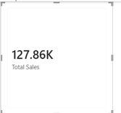
2. Total Transactions – Card
A Card visual displays the total number of transaction records. The dashboard shows 999 transactions, giving an overview of the transaction volume.
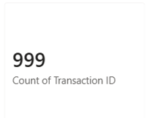
3. Average Total Spent – Card
A Card visual shows the average amount spent per transaction. The displayed average is 127.99, helping understand the typical spending value per transaction.
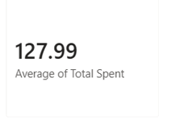
4. Total Spent by Location – Donut Chart
A Donut Chart compares total spending between Online and In-store sales. It shows that Online sales are 67.18K, while In-store sales are 60.69K, allowing easy comparison of the two sales channels.
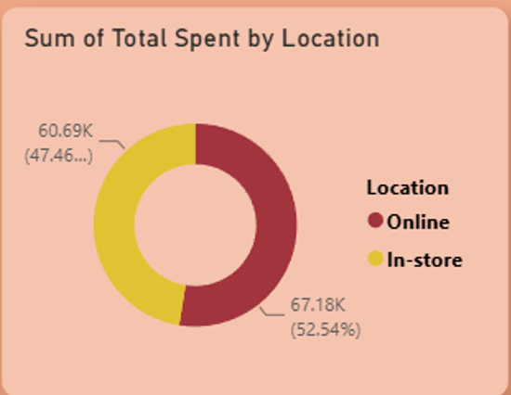

5. Total Spent by Category – Column Chart
A Column Chart compares total spending across different product categories. It helps identify the categories with higher and lower sales contributions, with Furniture showing the highest total spending among the categories displayed.

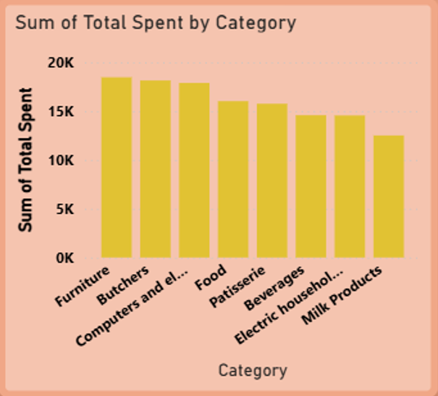
6. Total Spent by Payment Method – Pie Chart
A Pie Chart shows the distribution of total spending across Cash, Credit Card, and Digital Wallet payment methods. It helps compare the contribution of each payment method to overall spending.

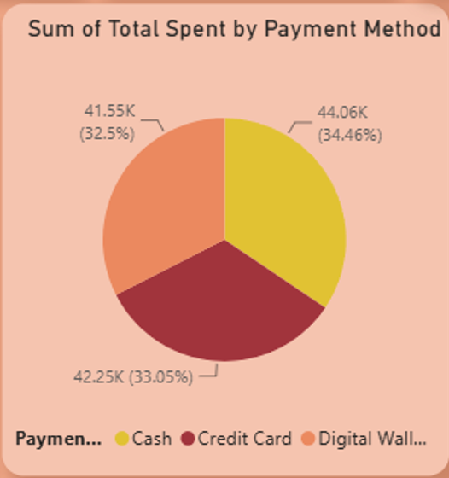

7. Total Spent by Year – Line Chart
A Line Chart presents the change in total spending across 2022, 2023, 2024, and 2025. It helps identify changes and trends in sales performance over the years.
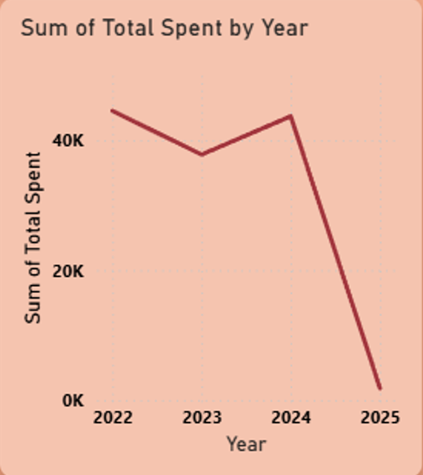
8. Category Slicer
A Category slicer was added to allow users to select a specific product category. Selecting a category dynamically filters the dashboard visuals based on that selection.

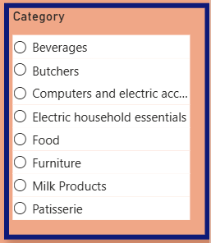
9. Location Slicer
A Location slicer allows users to filter the dashboard between In-store and Online transactions, making it easier to analyze sales by sales channel.
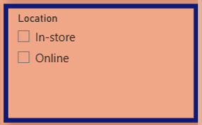
10. Transaction Date Slicer
A Transaction Date slicer allows users to select a specific date range. This provides interactive analysis of sales performance for the selected period.
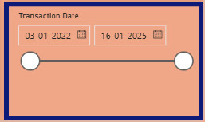

DASHBOARD

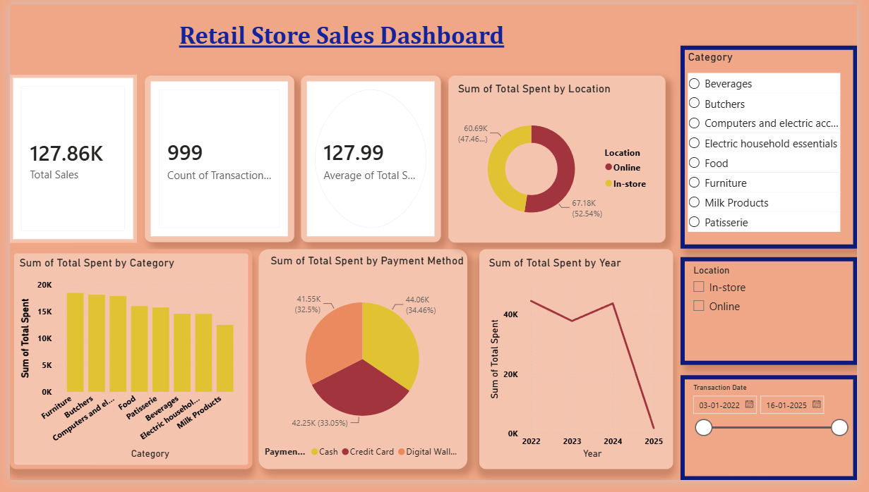

Final Analysis and Conclusion
The Power BI dashboard provides a clear overview of the retail store’s sales performance. The analysis shows total sales of 127.86K across 999 transactions, with an average transaction value of 127.99. Online sales contributed slightly more than in-store sales, while Furniture recorded the highest total spending among the categories. Cash recorded the highest total spending among the payment methods. The yearly analysis shows that 2022 recorded the highest total spending, followed by 2024 and 2023.

---------------------------------------------------------------------------------------

